
Facilitator - Mohamed Amine KOUBA
Secretary - Idris HACHI
Scribe - Joris BUFFET
Manager - Zahia Meriem ASSAM

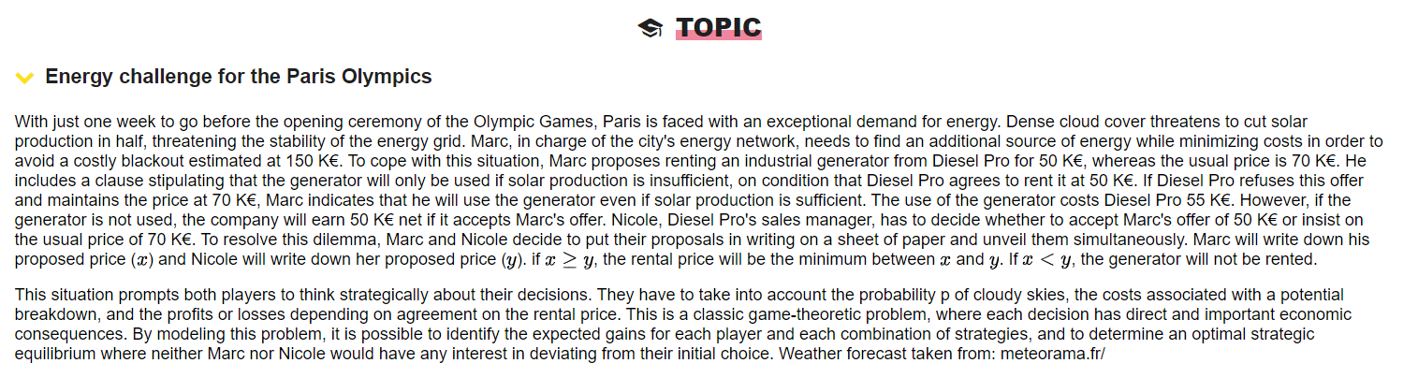
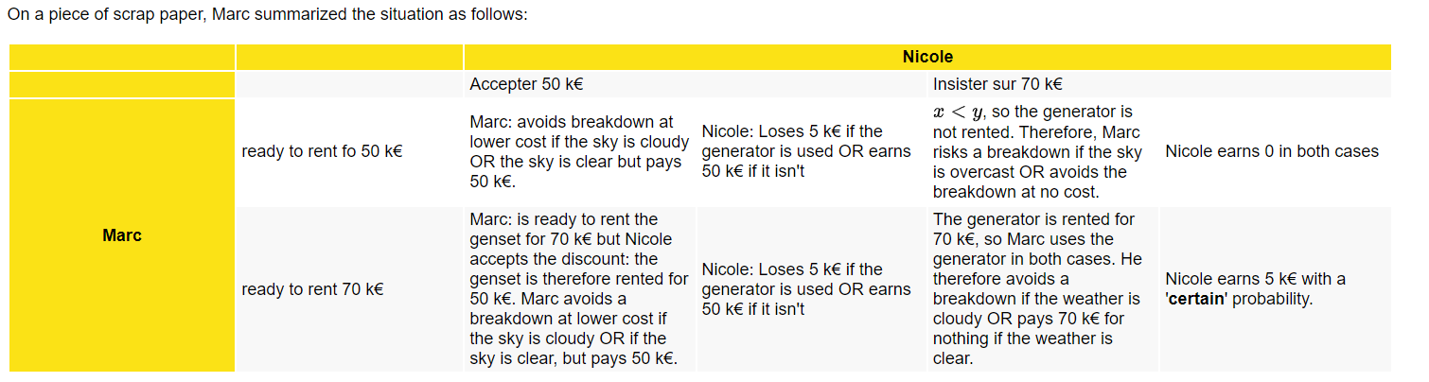
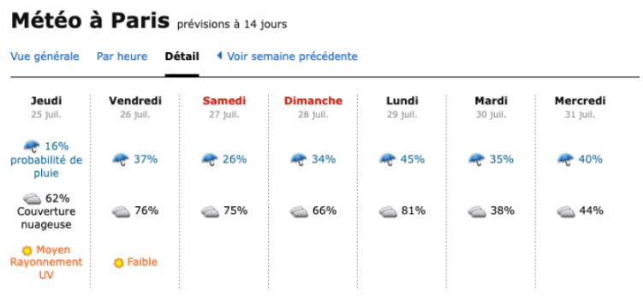
KEYWORDS
- Blackout and Breakdown - a failure of an electrical power supply.
- Solar production - Solar production measures the amount of electricity your solar system produces.
- Generator - a device that transforms mechanical energy into electrical energy.
- Energy - the capacity to do work.
- Probability - the chance or likelihood of a specific result or event occurring from among several potential options or outcomes. It serves as a mathematical measure of risk and uncertainty in engineering systems and processes.
- Game theory - the study of mathematical models of strategic interactions.
- Game-theoretic problems - involve strategic interactions where players' outcomes depend on both their own and others' actions. Players aim to maximize their payoffs in competitive or cooperative settings.
- Strategies - a plan of action designed to achieve a long-term or overall aim.
- Strategic equilibrium - a situation where each player's chosen strategy is the best response to the strategies chosen by others. The strategies are self-supporting ; illustrated by Nash equilibrium.

Context
As the Olympic Games approach, Paris faces potential energy shortages due to cloudy skies impacting solar production. Marc, managing the city's energy grid, negotiates with Nicole from Diesel Pro to rent a generator, aiming to avoid a costly blackout while minimizing expenses.

Problem Statement
How can Mark and Nicole optimize their strategies to convince each other without having too many losses?

Constraints
- The uncertainty of weather
- The generator price
- Only a week to go before the ceremony

Deliverables
Use probabilities and game theory strategies to find a solution.

Generalize
- Probability and game theory strategy
- Nash equilibria

Solution Approaches
- Application of game theories
- Risk analysis and decision making
- Weather forecast probabilities

Action Plan
- Study game theory and its strategies
- Analyze weather forecasts with probabilities
- Analyze the given data
- Find an optimal outcome
Action Plan - Answers
GAME THEORY
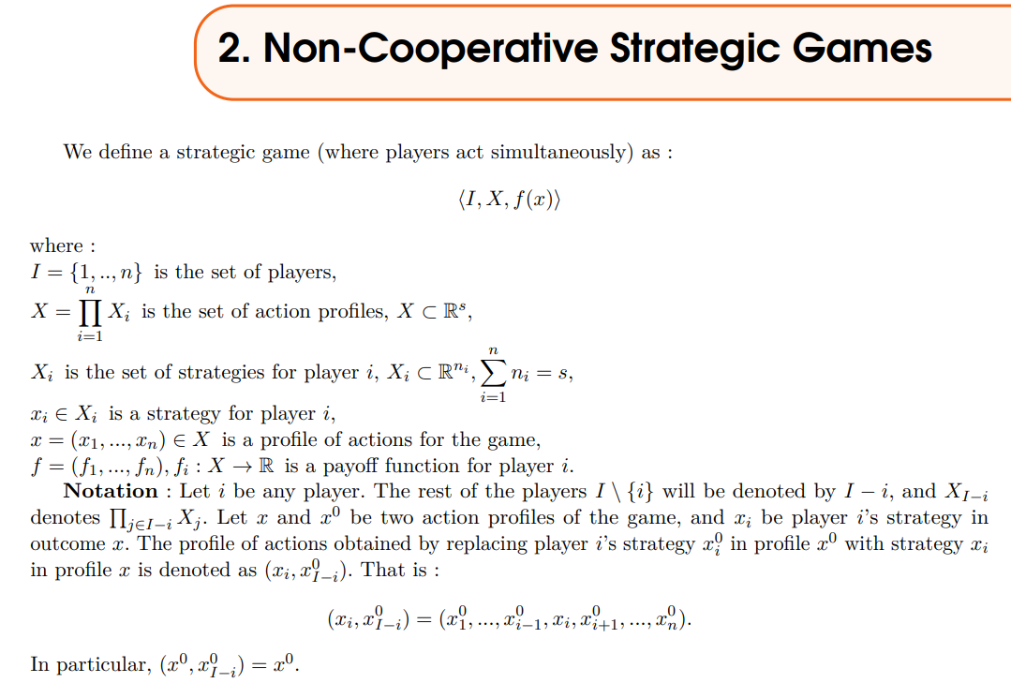
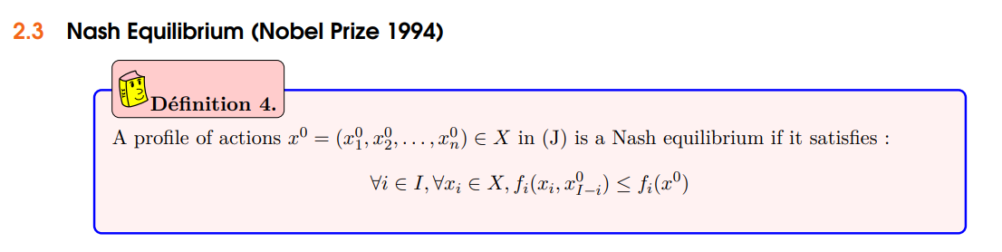
- Nash equilibrium in game theory is a situation in which a player will continue with their chosen strategy, having no incentive to deviate from it, after taking into consideration the opponent’s strategy.
- To find the Nash equilibrium in a game, one would have to model out each of the possible scenarios to determine the results and then choose what the optimal strategy would be.
- Nash equilibrium is important because it helps a player determine the best payoff in a situation based on not only their decisions but also the decisions of other parties involved.
- It can also be thought of as a "no regrets" outcome in the sense that once a decision is made, the player will have no regrets about it, considering the consequences.
- Strategy: A complete plan of action a player will take given the set of circumstances that might arise within the game.
- Equilibrium: The point in a game where both players have made their decisions and an outcome is reached.
PROBABILITY
Probability is the branch of mathematics concerning the occurrence of a random event, and four main types of probability exist: classical, empirical, subjective and axiomatic.
If an event has a probability of one, that tells you the event is certain and will happen.
Complementary events are two events that exist such that one event will occur if and only if the other does not take place. For two events to be classified as complementary events they must be mutually exclusive and exhaustive.
The binomial distribution is a commonly used discrete distribution in statistics. The binomial distribution represents the probability for 'x' successes of an experiment in 'n' trials, given a success probability 'p' for each trial at the experiment.

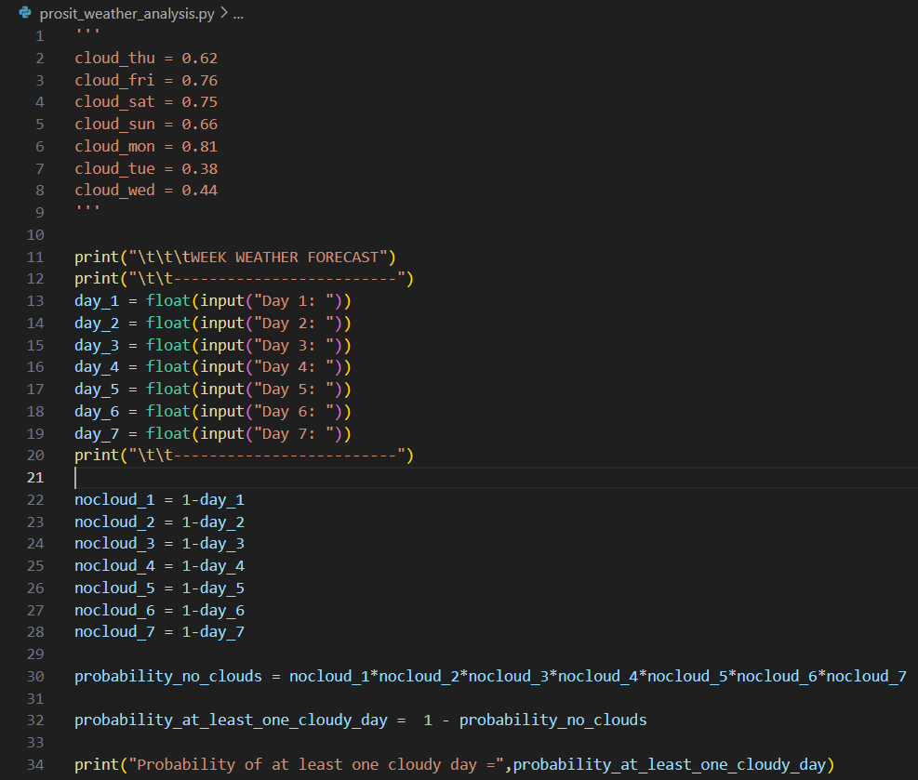
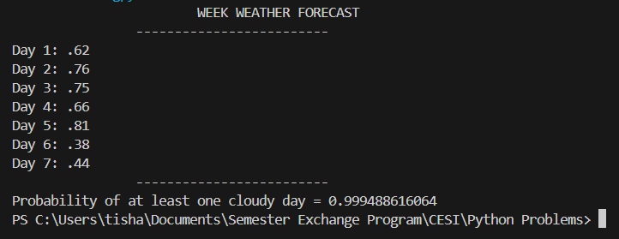
(# similar to exercise 2 – workshop)

ANALYZE THE GIVEN DATA

PREFERENCE FOR MARC:

PREFERENCE FOR NICOLE:

CONCLUSION
- (150P – 50, 50 – 55P) preferred for 0.2 > P > 0.64
- (150 P – 70, 15) preferred for P > 0.64

